BLOOMINGDALE BOUROUGH BOARD OF HEALTH
REGULAR MEETING MINUTES – April 2, 2018

- Call to Order.
Ms. Petersen called the meeting to order at 7:35 p.m.

- Roll Call.
Present: Petersen, Innamorato, Carney, Fallon and Lovelace
Also Present: Gail Gratzel, Assistant Health Officer; Susan DeGraw, Public Health Nurse and Lauren Lombardo, Student Intern

- Poison Prevention Poster Contest
Ms. DeGraw worked with board members as they chose winners for the upcoming awards ceremony. Board members chose a first, second, third and honorable mention for third and fourth grade participating students.

- Four Town Health Challenge
Ms. Gratzel distributed some rough draft information on the Four Town Health Challenge and gave some background information on the project. Ms. Lombardo expanded on the program in more detail and board members had an opportunity to comment on the project. The program will run for nine weeks this summer.

- Approval of Minutes.
Motion was made by Ms. Carney to approve the February 5, 2018 minutes as presented. This motion was seconded by Ms. Fallon and was unanimously approved. Motion was made by Ms. Fallon to approve the March 5, 2018 minutes as presented. This motion was seconded by Mr. Lovelace and was unanimously approved.

- Acceptance of Reports
After discussion of the presented reports on motion by Ms. Carney with a second by Ms. Innamorato the Health Department monthly report, Retail Food Inspection Summary Report and Year to Date Reports were approved as submitted and unanimously approved.

- Unfinished Business
Mayor’s Wellness Campaign: Ms. Gratzel will contact Mayor Dunleavy with regards to the Four Town Wellness Challenge. This program can be run under the Mayor’s Wellness Campaign. All Mayor’s and Town Administrators will be notified of the program and will be invited to participate in any of the walks, kick off and grand finale.
Stigma Free: Ms. Gratzel reported that another Mental Health First Aid Class had just recently been completed in March with nine people attending. Mr. Lovelace attended the class and gave positive feedback to board members. Ms. Gratzel reported that she is currently collaborating with Passaic County Mental Health Association in order to implement a Youth Mental Health First Aid Class, planning for two consecutive Saturdays in May.
Poison Prevention: Ms. Gratzel said that the awards ceremony for the poster contest will be held at the next board of health meeting scheduled for May 7th.

- Public Discussion
Motion was made by Ms. Fallon to open the meeting to public discussion. This motion was seconded by Ms. Innamorato and all voted in favor. As there was no public wishing to address the Board, motion was made by Ms. Carney to close the meeting to public discussion. This Motion was seconded by Ms. Innamorato and all voted in favor.

- Adjournment
Motion was made by Mr. Lovelace to adjourn the meeting at 8:40 p.m. This Motion was seconded by Ms. Fallon and all voted in favor.

Approved:
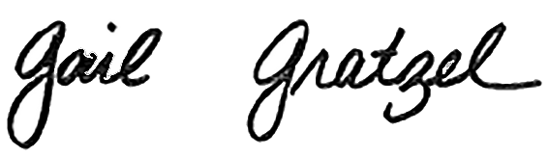
Gail Gratzel, MPH
Assistant Health Officer

